5.Creating Microservices for Account & Loan

Introduction
This project demonstrates a simple Spring Boot microservices architecture with two services:
- Account Service (port 8080) – returns account info
- Loan Service (port 8081) – returns loan details
Each service runs independently and communicates via REST, showing how microservices enable modular, scalable applications.

PART 1: ACCOUNT MICROSERVICE (PORT 8080)

Step 1: Project Setup
- Visit: https://start.spring.io
- Fill in the following:
  - Group: com.cognizant
  - Artifact: account
- Select Dependencies:
  - Developer Tools → Spring Boot DevTools
  - Web → Spring Web
- Click Generate
- Extract and place it inside:
D:\6422868\ microservices\account
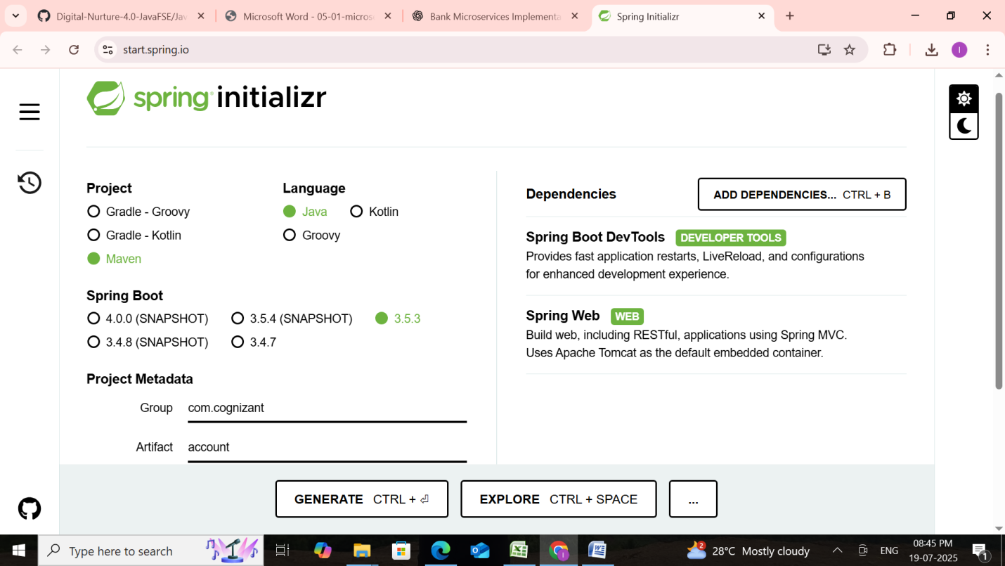

Step 2: Build the Project
Open Command Prompt:
cd D:\6422868\microservices\account
mvn clean package

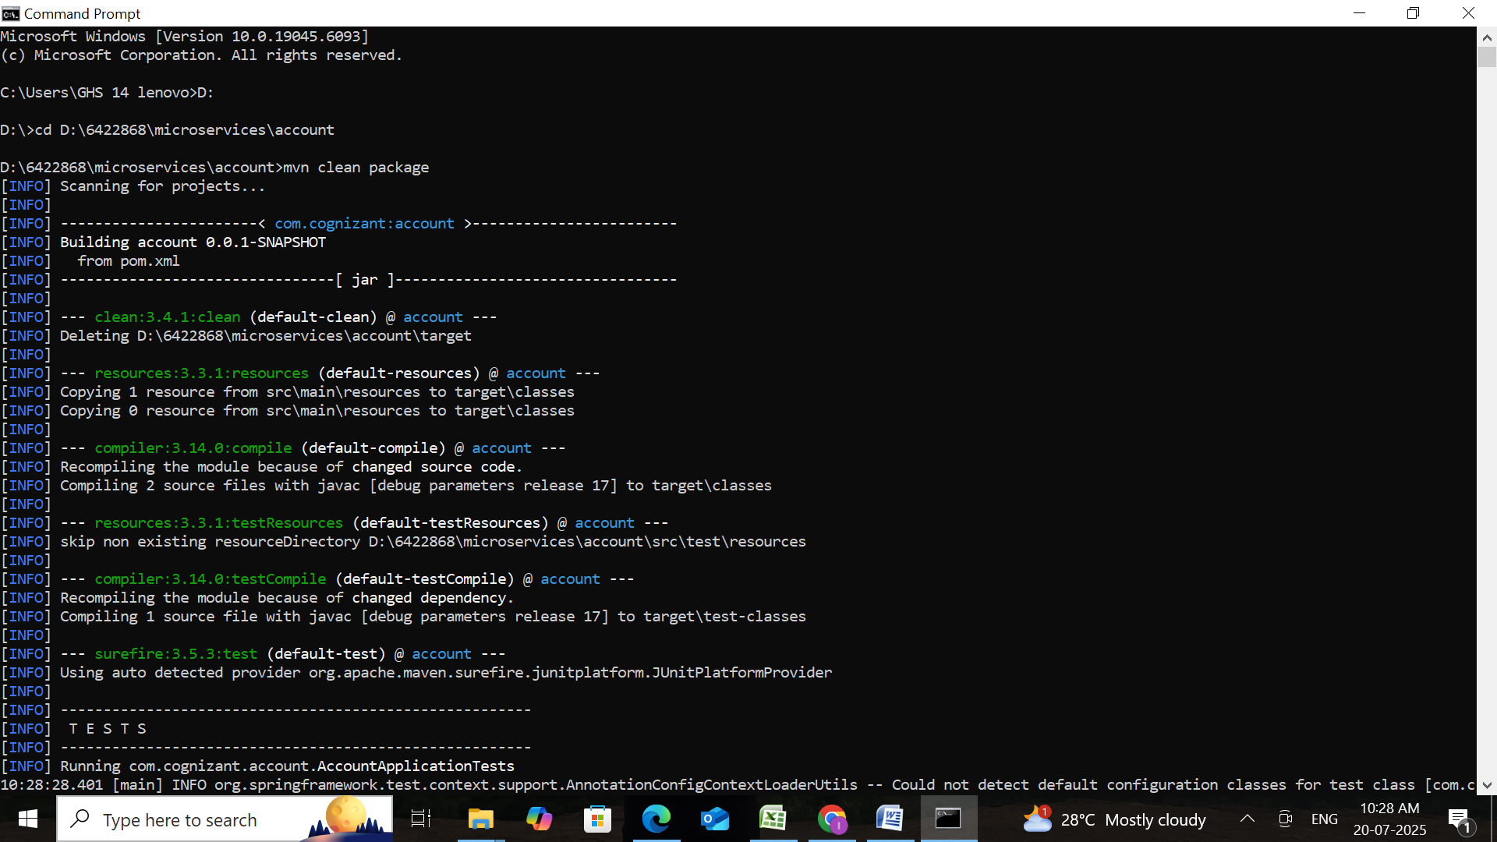

Step 3: Import to Intellij
- Open Intellij IDE
- Go to File → Import → Existing Maven Project
- Browse to: D:\6422868\microservices\account
- Click Finish
Step 4: Create Controller
Location: src/main/java/com/cognizant/account/controller/AccountController.java
AccountController.java
package com.cognizant.account.controller;
import org.springframework.web.bind.annotation.*;
import java.util.Map;
@RestController
@RequestMapping("/accounts")
public class AccountController {
@GetMapping("/{number}")
public Map<String, Object> getAccountDetails(@PathVariable String number) {
return Map.of(
"accountNumber", number,
"accountType", "Savings",
"holderName", "Priya Ramesh",
"balance", 764530.75,
"branch", "Chennai - T Nagar",
"ifsc", "CNRB0001234"
);
}
@GetMapping("/")
public String intro() {
return "Welcome to the Account Service - provides account-related information";
}
@GetMapping("/thankyou")
public String conclusion() {
return "Thank you for using the Account Service!";
}
}

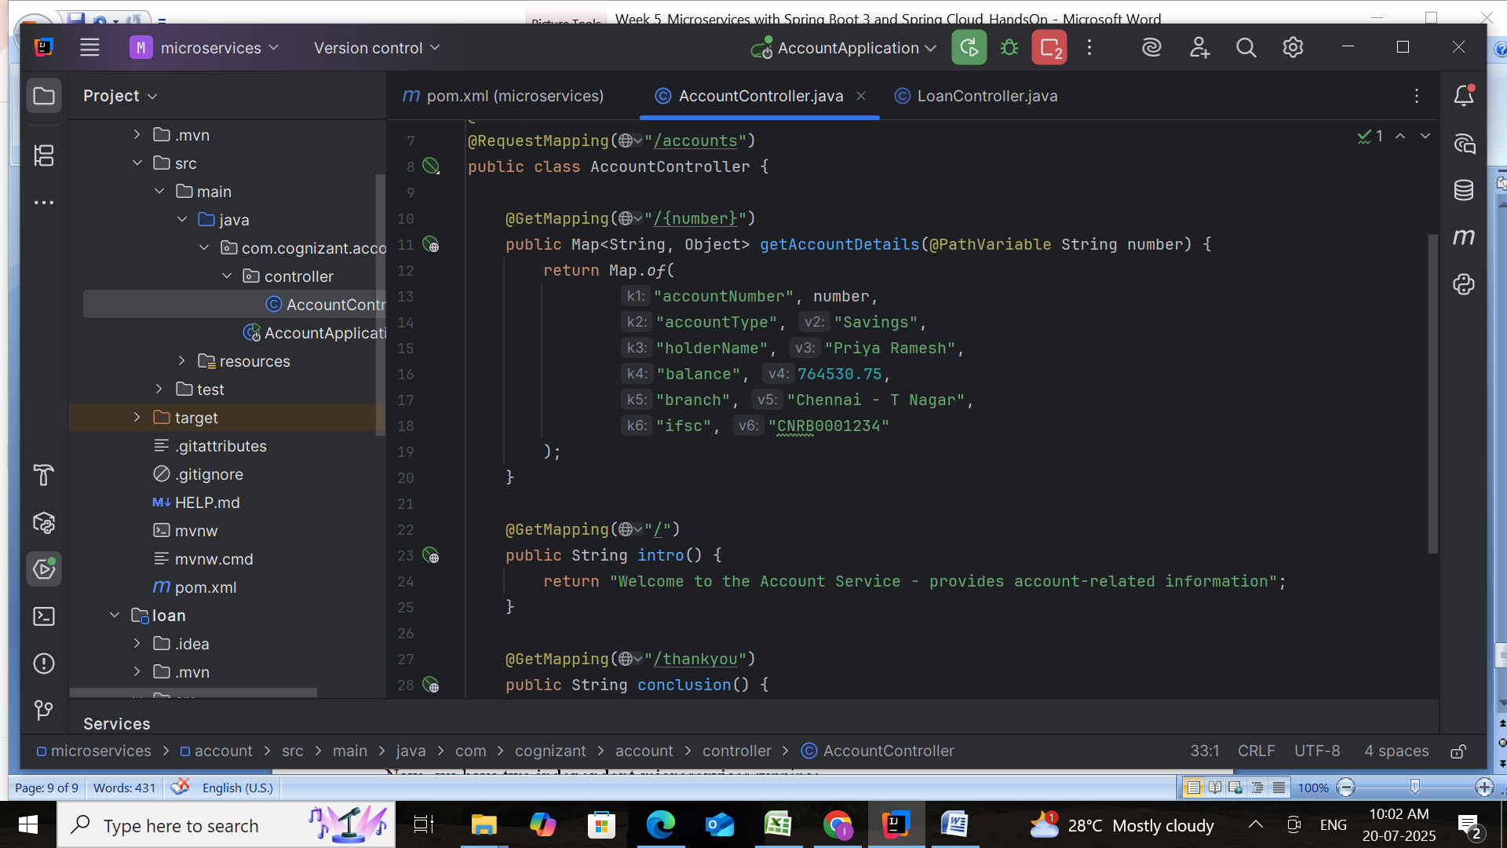

Step 5: Run and Test
- Run AccountApplication.java
- Visit URL:
http://localhost:8080/accounts/ACC98765
AccountApplication.java
package com.cognizant.account;
import org.springframework.boot.SpringApplication;
import org.springframework.boot.autoconfigure.SpringBootApplication;
@SpringBootApplication
public class AccountApplication {
public static void main(String[] args) {
SpringApplication.run(AccountApplication.class, args);
}
}

- http://localhost:8080/accounts/ACC98765
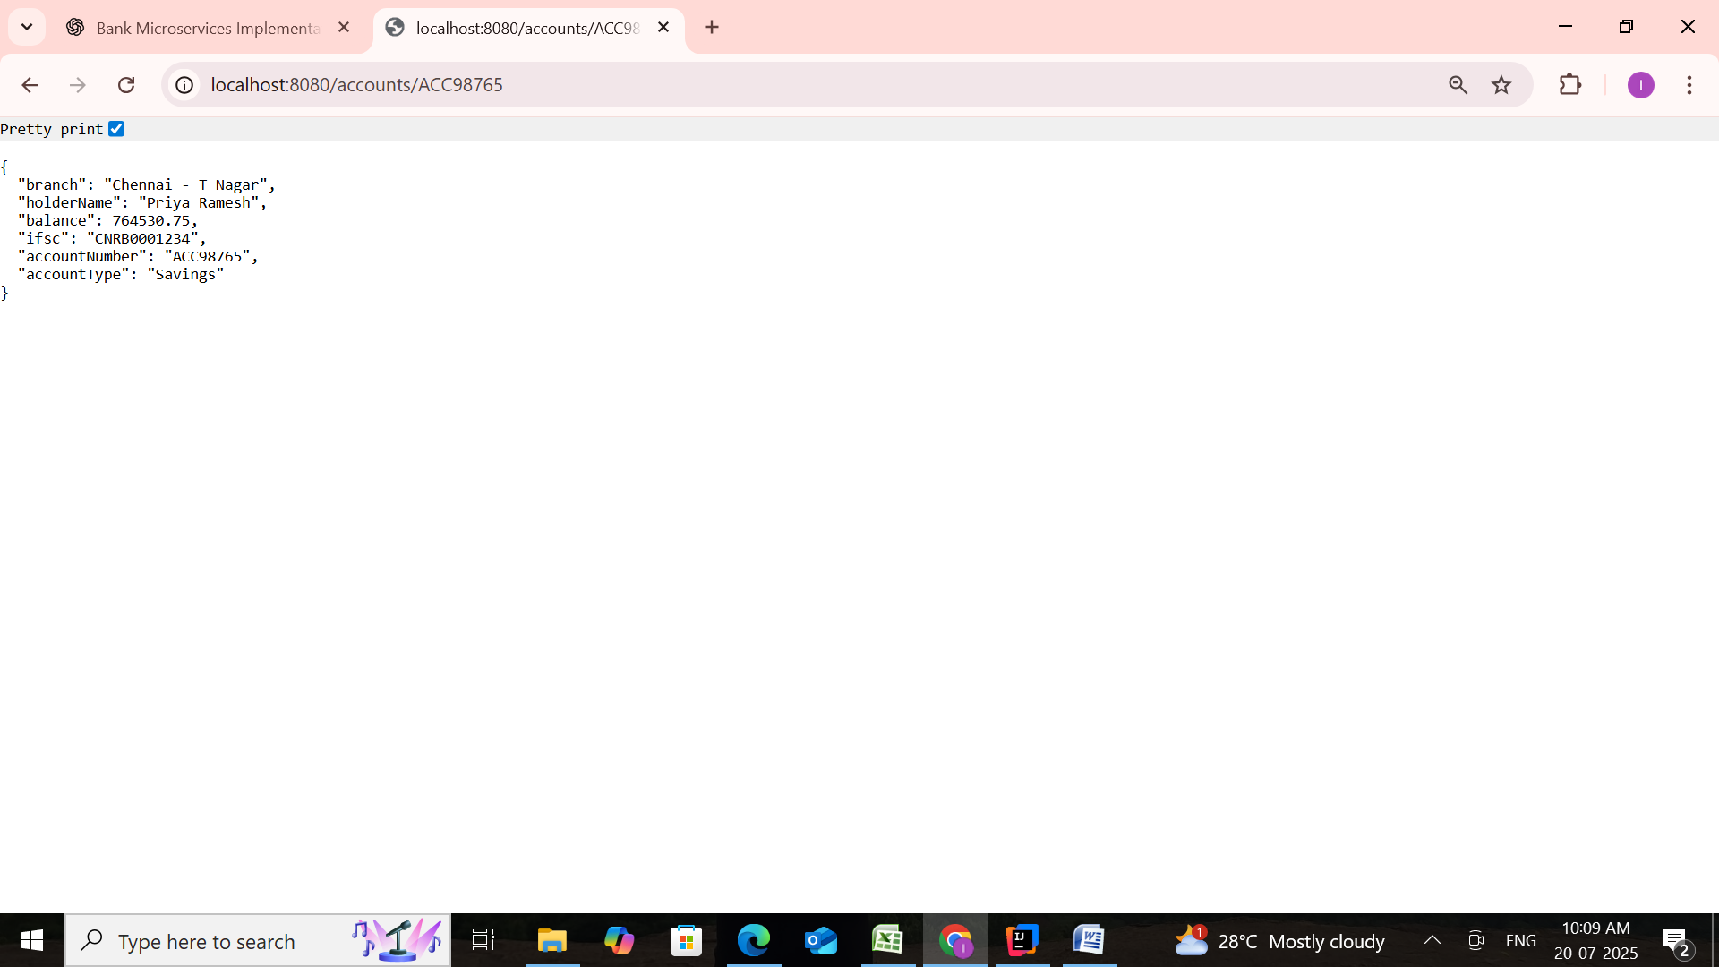
- http://localhost:8080/accounts/thankyou
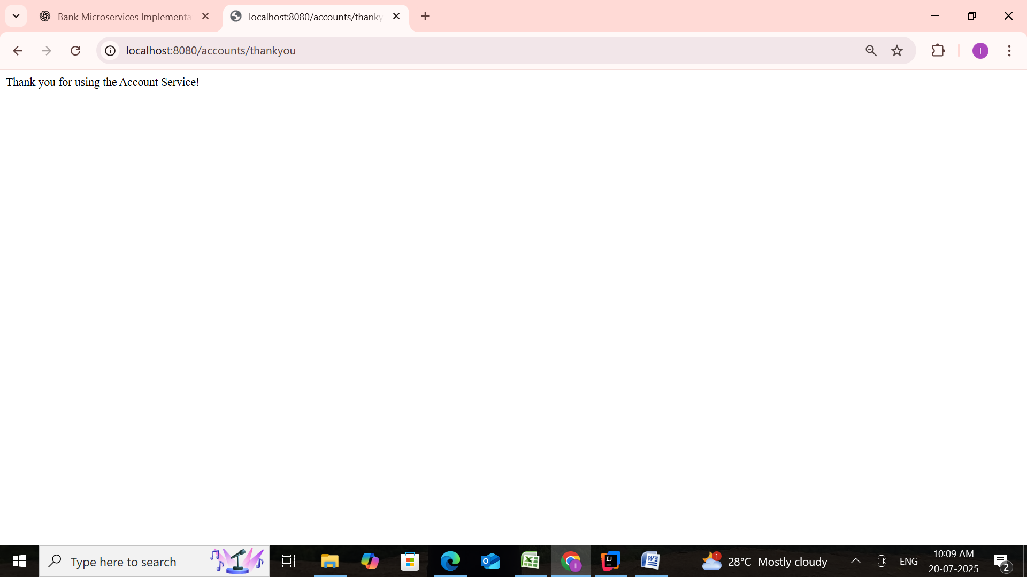

PART 2: LOAN MICROSERVICE (PORT 8081)

Step 1: Project Setup
Repeat steps at https://start.spring.io
- Group: com.cognizant
- Artifact: loan
- Dependencies:
  - Spring Boot DevTools
  - Spring Web
Extract and place it inside:
D:\6422868\microservices\loan
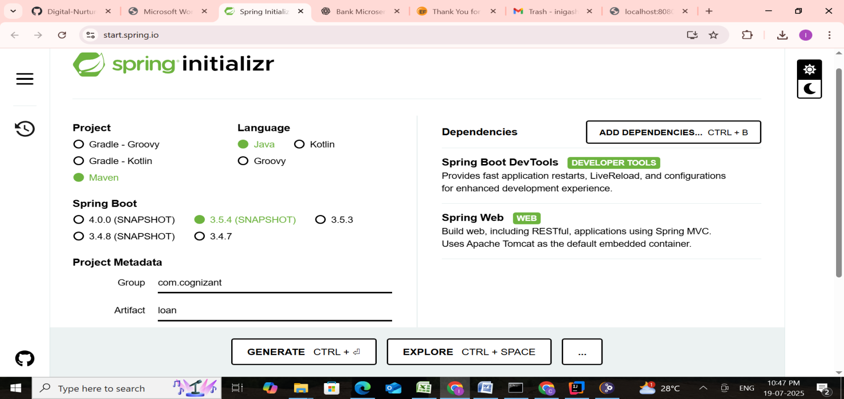

Step 2: Build the Project
cd D:\6422868\microservices\loan
mvn clean package

Step 3: Import to Intellij
- File → Import → Existing Maven Project
- Browse:
D:\6422868\microservices\loan
- Finish import

Step 4: Change Default Port
In src/main/resources/application.properties, add:
server.port=8081

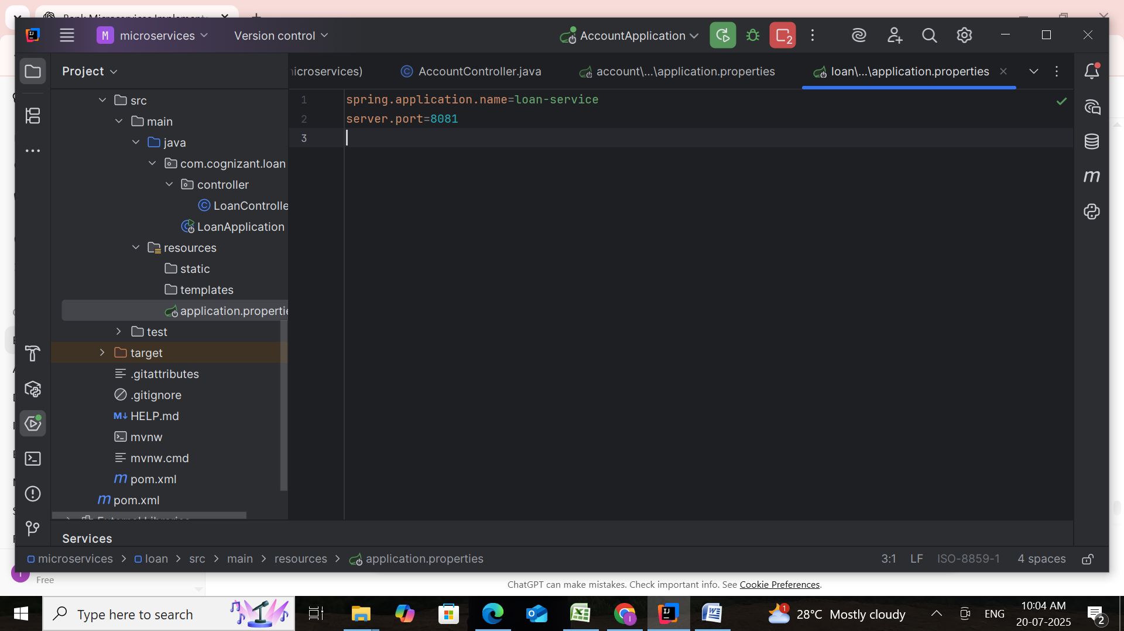

Step 5: Create Controller
Location: src/main/java/com/cognizant/loan/controller/LoanController.java

LoanController.java
package com.cognizant.loan.controller;
import org.springframework.web.bind.annotation.*;
import java.util.Map;
@RestController
@RequestMapping("/loans")
public class LoanController {
@GetMapping("/{loanId}")
public Map<String, Object> getLoanDetails(@PathVariable String loanId) {
return Map.of(
"loanId", loanId,
"loanType", "Home Loan",
"borrowerName", "Priya Ramesh",
"loanAmount", 2500000.0,
"emi", 25240.50,
"durationYears", 15
);
}
@GetMapping("/")
public String intro() {
return "Welcome to the Loan Service - provides loan-related information";
}
@GetMapping("/thankyou")
public String conclusion() {
return "Thank you for using the Loan Service!";
}
}

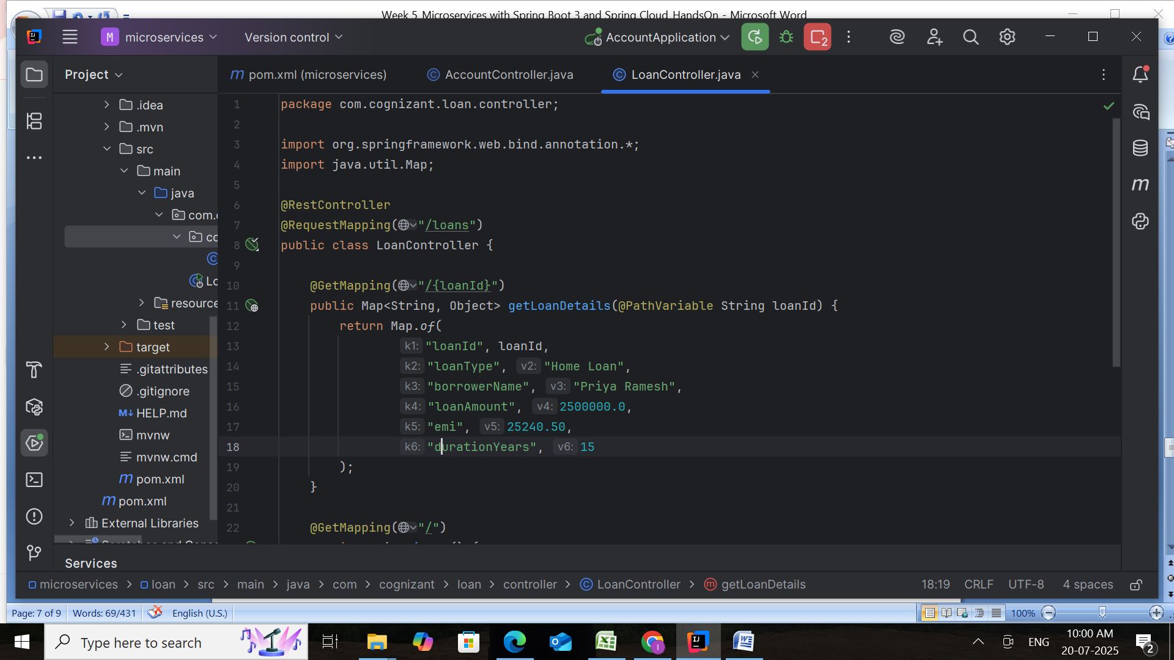

LoanApplication.java
package com.cognizant.loan;
import org.springframework.boot.SpringApplication;
import org.springframework.boot.autoconfigure.SpringBootApplication;
@SpringBootApplication
public class LoanApplication {
public static void main(String[] args) {
SpringApplication.run(LoanApplication.class, args);
}
}

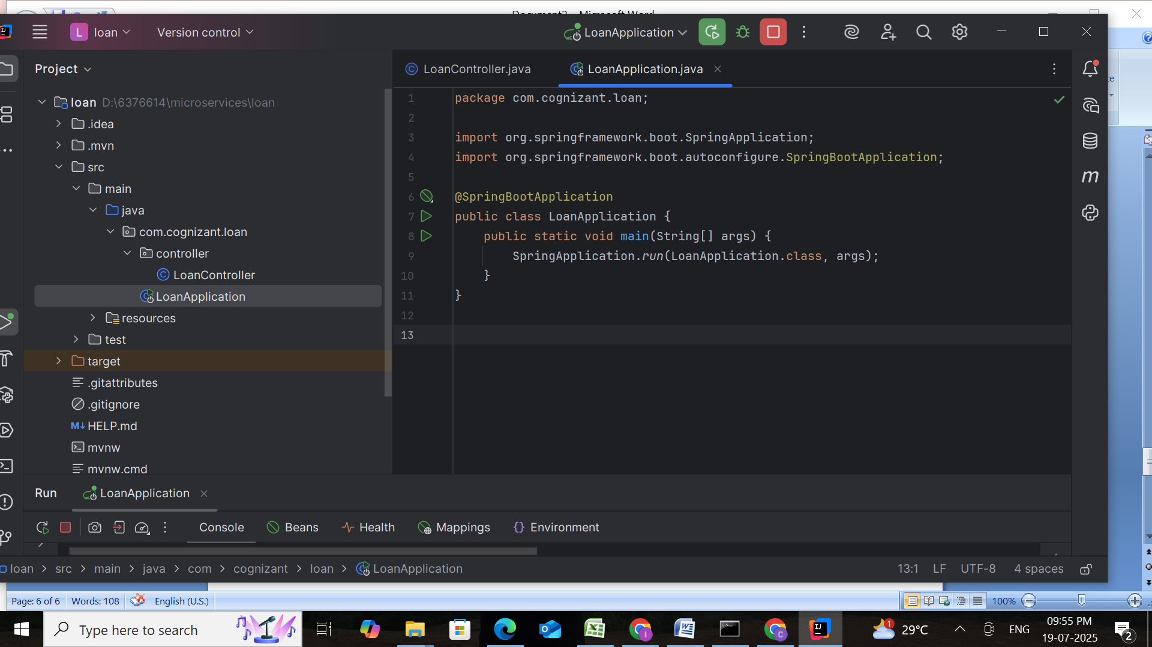

Step 6: Run and Test
- First, ensure Account service is already running.
- Then, run LoanApplication.java
- Visit URL:
http://localhost:8081/loans/LN12345
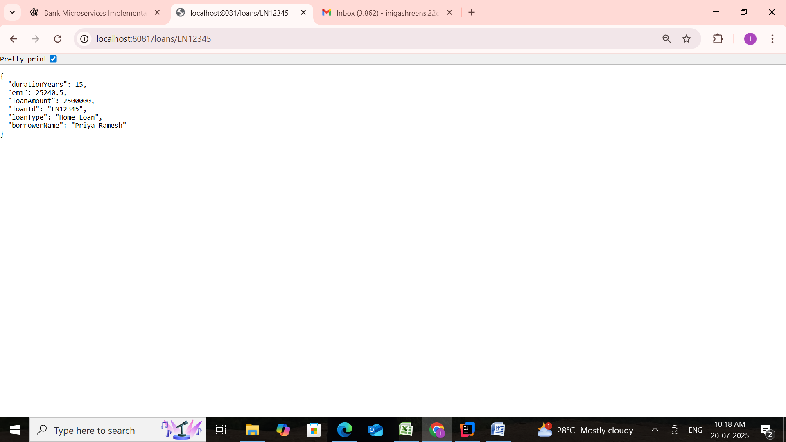

- http://localhost:8081/loans/thankyou
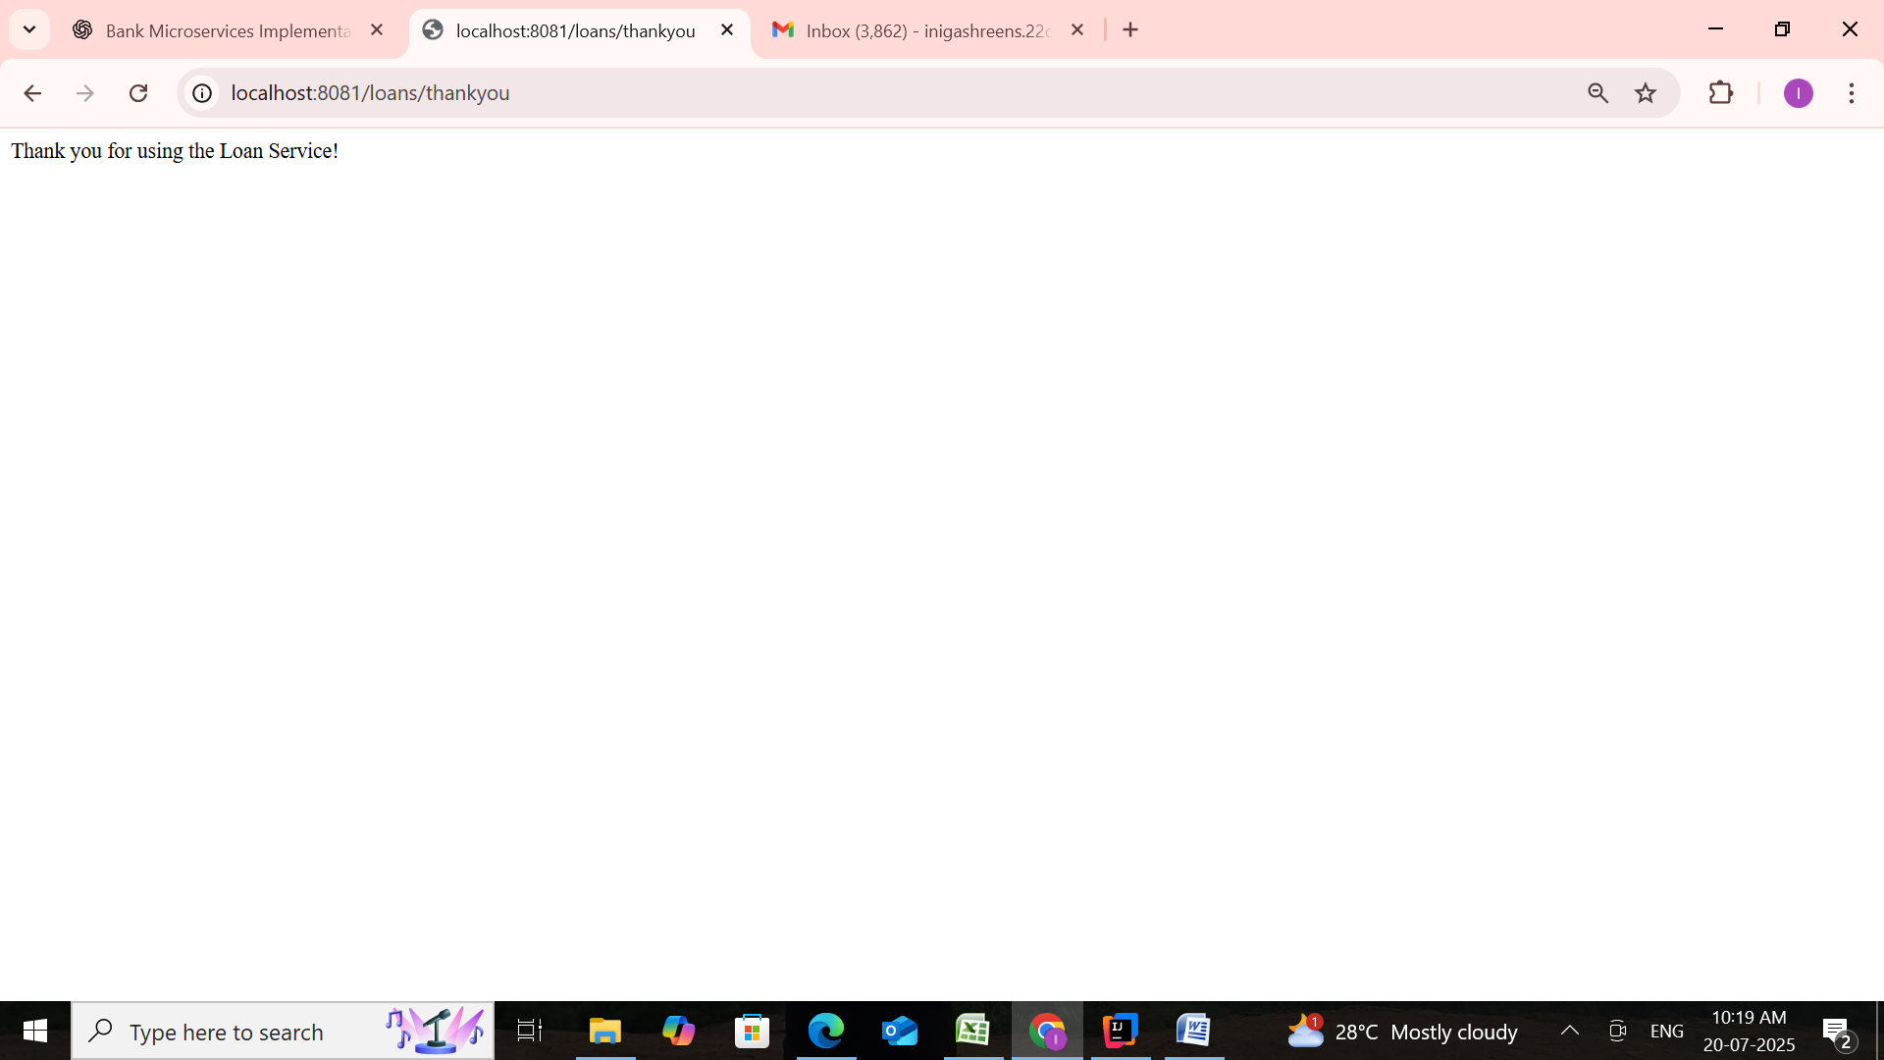

Conclusion
In this project, we demonstrated a simple yet effective implementation of Microservices Architecture using Spring Boot. Two independent services were created — Account Service and Loan Service — each running on separate ports (8080 and 8081 respectively) and capable of providing account-related and loan-related information through REST APIs.
This modular approach shows the benefits of microservices, such as:
- Scalability: Services can be scaled independently.
- Flexibility: Easy to update or maintain one service without affecting others.
- Clarity: Separation of business logic makes the system easier to understand and extend.
By calling endpoints like /accounts/{number} or /loans/{loanId}, users can fetch detailed data in a structured JSON format. The addition of introduction and thank-you routes adds a user-friendly interface to each service.
This foundational project serves as a great starting point for building larger distributed applications using microservices in real-world systems like banking, insurance, or e-commerce platforms.
.
